**OBJECTIVE 5**

1. **WAP using function for checking whether two numbers are equal or not with return.**

**Source Code**

def function(a,b):

if a==b:

return 1

else:

return 0

a=eval(input("enter the number1 :"))

b=eval(input("enter the number2 :"))

z=function(a,b)

if z==1:

print(a," and ",b," are equal")

elif z==0:

print(a," and ",b," are not equal")

**Output**

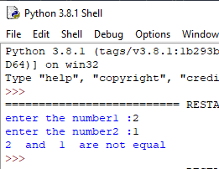

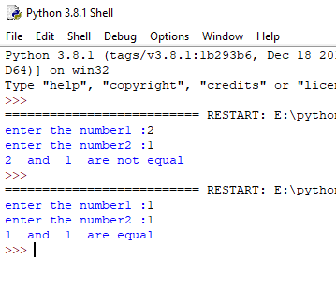

1. **WAP to return full name of a person using fuction.**

**Source Code**

def name(z):

return z;

z=str(input("enter the name of person :"))

k=name(z)

print("name =>",k)

**Output**

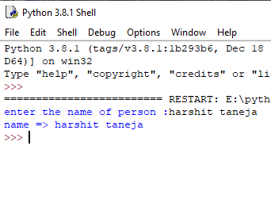

1. **WAP to calculate GCD of two numbers using recursion.**

**Source Code**

def gcd(a,b):

if b==0:

return a;

else:

return gcd(b,a%b)

print("enter numbers :")

a=eval(input())

b=eval(input())

z=gcd(a,b)

print("GCD of ",a,"and ",b,"is :",z)

**Output**

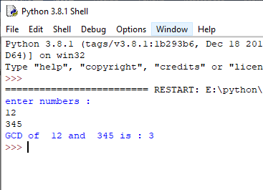

1. **WAP to print Fibonacci series using recursion**

**Source Code**

def fib(n):

if n==0:

return 0;

elif n==1:

return 1;

else:

return fib(n-1) +fib(n-2);

n=eval(input("enter the no size :"))

for i in range(0,n):

z=fib(i)

print(z,end=" ")

**Output**

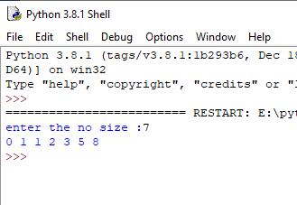

1. **WAP to calculate factorial of 10 different numbers using function.**

**Source Code**

def fact(z):

if z==1:

return 1;

else:

return z*fact(z-1);

for i in range(0,11):

z=eval(input("enter the number :"))

l=fact(z);

print(l)

**Output**

>>>

========================= RESTART: E:\python\code 5.py =========================

enter the 0 number :

2

factorial of 2 is : 2

enter the 1 number :

3

factorial of 3 is : 6

enter the 2 number :

4

factorial of 4 is : 24

enter the 3 number :

5

factorial of 5 is : 120

enter the 4 number :

6

factorial of 6 is : 720

enter the 5 number :

7

factorial of 7 is : 5040

enter the 6 number :

8

factorial of 8 is : 40320

enter the 7 number :

9

factorial of 9 is : 362880

enter the 8 number :

10

factorial of 10 is : 3628800

enter the 9 number :

11

factorial of 11 is : 39916800

enter the 10 number :

12

factorial of 12 is : 479001600

>>>

1. **WAP to print next 15 leap year from the given year.**

**Source Code**

print("Enter a range to check it is leap year or not : ")

n1=eval(input());

n2=eval(input());

for i in range(n1,n2+1):

if i%4==0:

if i%100:

if i%400:

print("\n\n \n",i)

else:

print(i)

**Output**

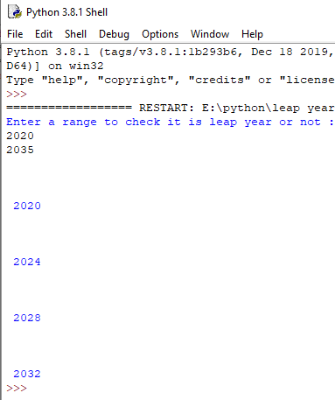

1. **WAP to print Armstrong number from 1 to 9999 using function.**

**Source Code**

print(" armstrong number between 1 and 10000:")

sum=0

for i in range(1,10000):

l=i

count=0

while(l!=0):

l=l//10

count=count+1;

sum=0

z=i

while(z!=0):

rem=z%10

k=rem**count

sum=sum+k;

z=z//10

if(i==sum):

print(i,end=" ")

**Output**

